|  |
| --- |
| [Invisible shadow] |
| Unsteadyland |
| **[Help the astronaut survive]** |
| Version #1.0.5  All work Copyright © 2021 by Invisible Shadow Games.  All rights reserved. |
| **[Rui Chen Geng Li - 101277255]** |
|  |

|  |
| --- |
| November 21st 2021 |

**Table of Contents**

* Version History ------------------------------------------------------------ Pg 3
* Detailed Game Description --------------------------------------------- Pg 4
* Controls ---------------------------------------------------------------------- Pg 4
* Interface Sketches --------------------------------------------------------- Pg 5
* Screen Description -------------------------------------------------------- Pg 5
* Game World ---------------------------------------------------------------- Pg 9
* Levels ------------------------------------------------------------------------- Pg 9
* Characters / Vehicles ---------------------------------------------------- Pg 10
* Enemies (AI) --------------------------------------------------------------- Pg 10
* Weapons ------------------------------------------------------------------- Pg 10
* Scoring ----------------------------------------------------------------------- Pg 11
* Sound Index ---------------------------------------------------------------- Pg 11
* Art / Multimedia ---------------------------------------------------------- Pg 11

**Version History**

Version 1.0.0 – Blank Project and GDD

Version 1.0.1 – Added Player, Enemies, Loots Sprites

Version 1.0.2 – Added Fonts and populated UIs

Version 1.0.3 – Added and implemented scene change functionalities

Version 1.0.4 – Added sound assets (SFX and background music)

(Current) Version 1.0.5 – Finalized scene layouts for draft #1

1. **Game Overview**

*The astronaut must survive long enough (for the duration indicated by the timer displayed on the screen), during which it will need to defeat monsters and collect loots to obtain ammo and increase score.*

1. **Game Play Mechanics**

*The player can defeat the monsters by performing close range attacks (with the sword) or by shooting them with a rifle. Each kill will increase the score by a specific amount. The player will also be able to pick up random loots (to increase the score), health potions (to increase the live counts), and ammo chests (to replenish/add extra ammunitions). The player can be killed on contact with the enemies, as well as by falling into the abyss, and by stepping on explosive platforms (red). Solid platforms are safe for the player to stand on, and slippery platforms (blue) have a decreased coefficient of friction using a physics material that make movements a bit tricky.*

1. **Camera**

*2D orthographic view from the camera. The start scene however, will use 2 cameras, one for the UI and one for the game objects. This is done so that the instruction menus can clearly show the appropriate icons (health, loots, weapons, etc.) in their correct positions.*

1. **Controls**

*The game uses a joystick to control the player’s movements. Button A for attack, J for jump, and C for changing weapons (between the sword – short range, and the rifle – long range).*

1. **Saving and Loading**

*Currently, since there is only one level. The only saving functionality present is by using a public static class to pass the player’s final score and state (win/lose) to the end scene.*

1. **Interface Sketch**

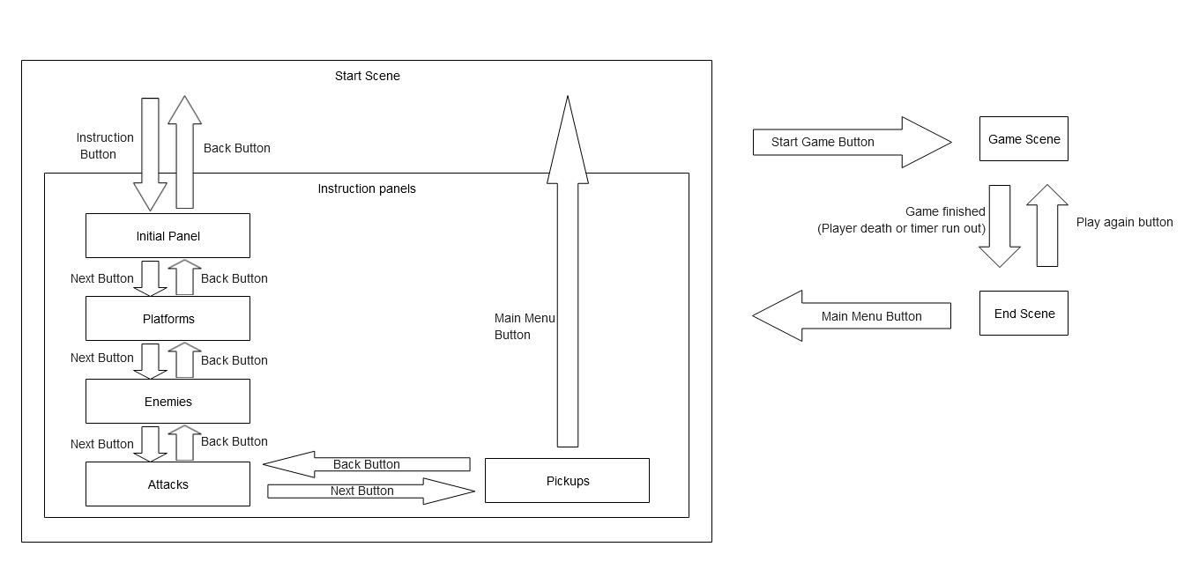

1. **Menu and Screen Descriptions**

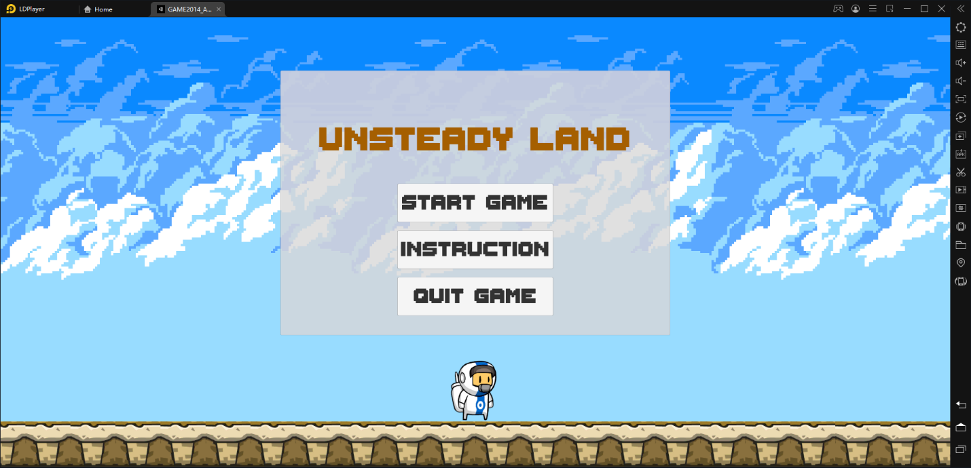

*Start Screen – The initial scene when game is loaded. Player can start the game, go to the instruction screens, or quit.*

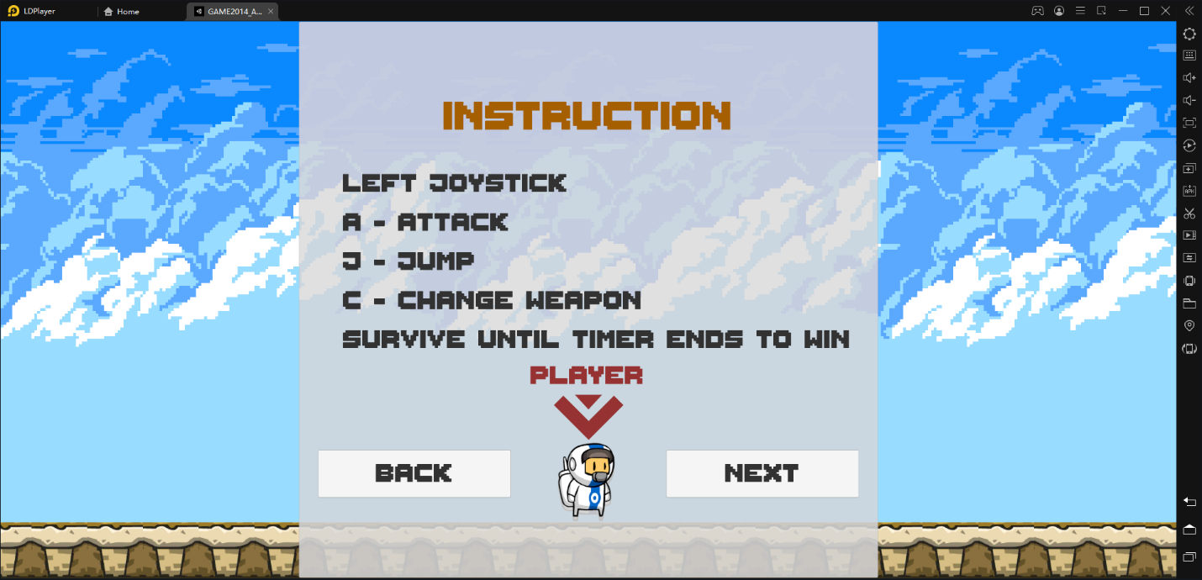

*Instruction Screen 1 – Shows the controls for how to play the game*

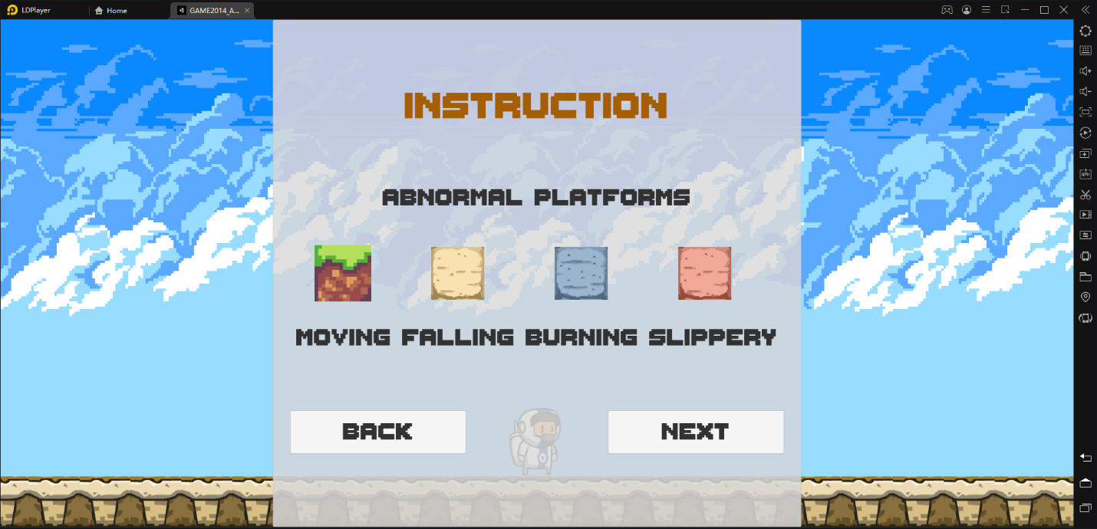

*Instruction Screen 2– Types of abnormal platforms in the game (does not include the regular solid platforms like the one the player is currently standing on)*

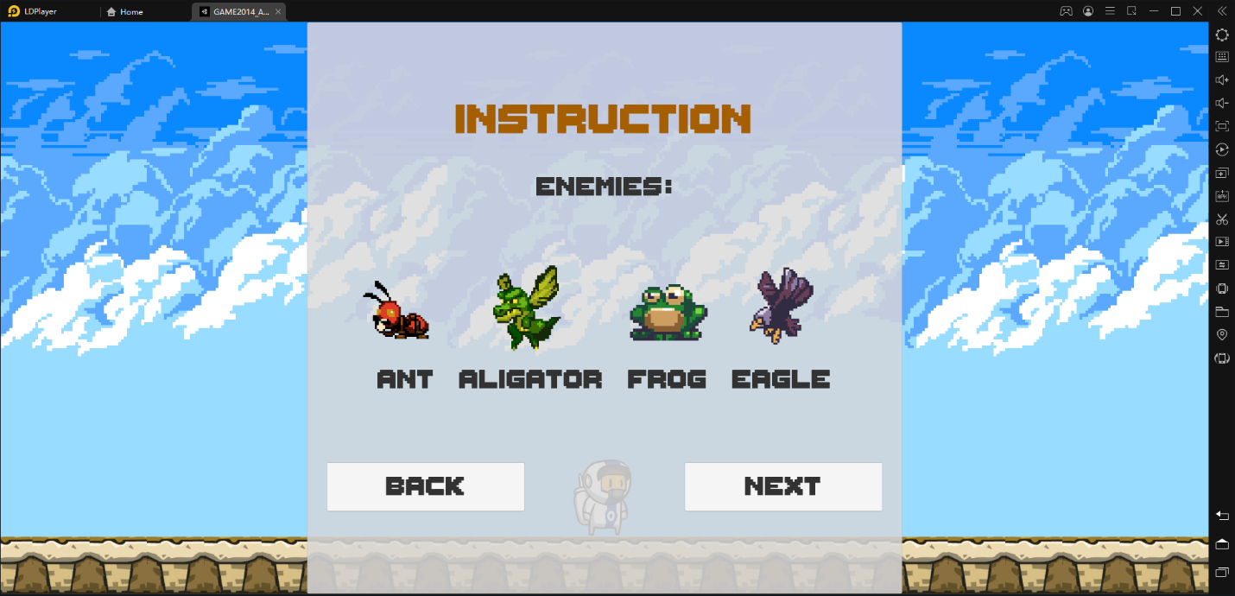

*Instruction Screen 3 – Types of enemies/monsters the player will encounter*

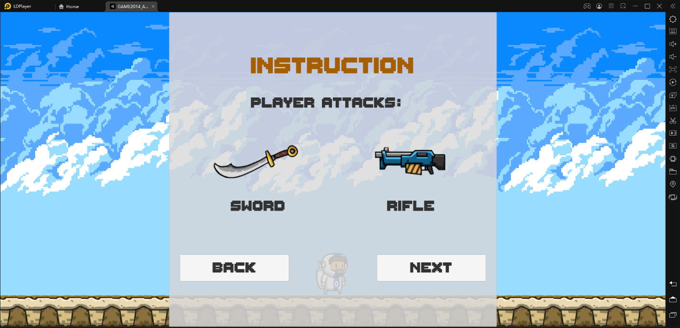

*Instruction Screen 4 – Types of attacks the player can use (sword – short range, rifle – long range)*

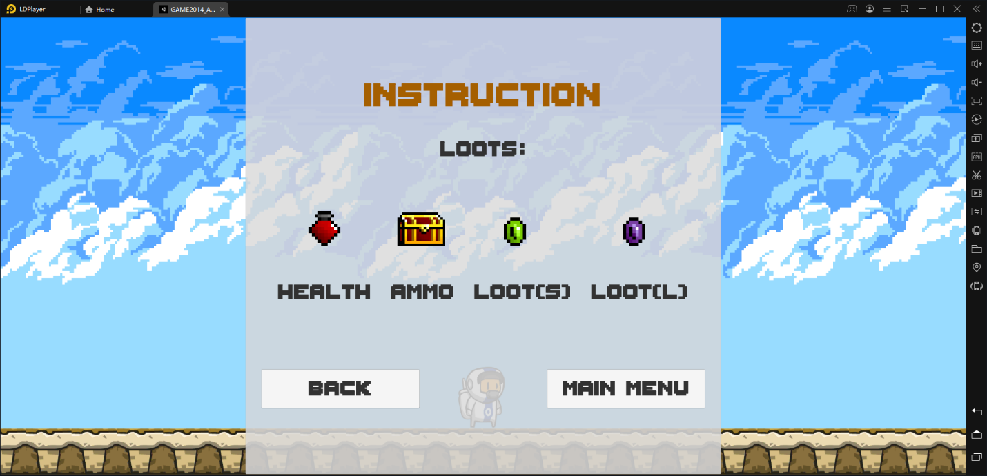

*Instruction Screen 5 – Types of loots randomly spawned in the game that the player can collect (health, ammo chest, small loot, large loot)*

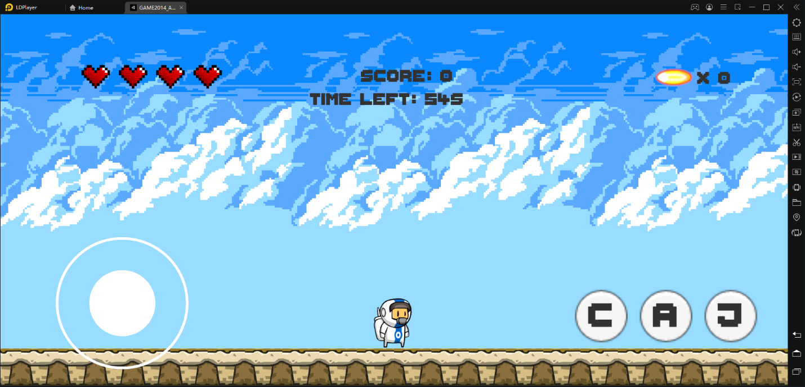

*Game Screen – Where the actual gameplay will occur. Contains the controls, UIs, player, platforms, and enemies.*

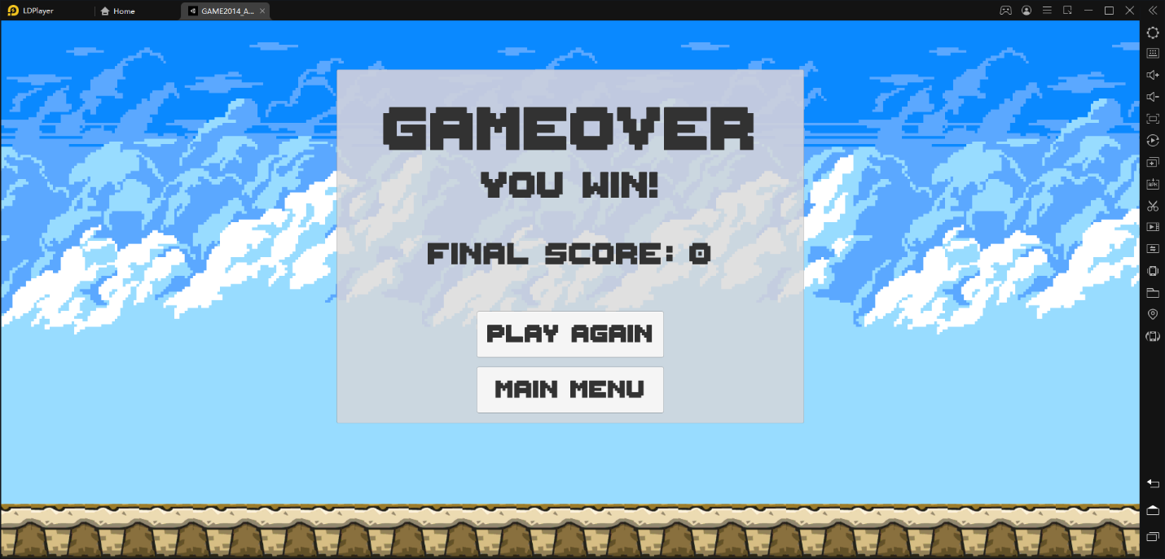

*End Screen – Displayed when the game is over, along with the player’s score and the state (win/lose). Gives the player the option to play again or go back to the main screen.*

1. **Game World**

*A happy looking environment but filled with enemies and abnormal platforms. The moving platforms (grass) will be translating up/down, left/right or diagonally. The fall-able sandy (yellow) platform will fall within a second the player lands on it. The slippery platform (blue) will have a decreased surface friction that will cause the player to slide around and harder to stop. The explosive (red) platform will flash before blowing up, within a second the player lands on it.*

1. **Levels**

*Currently there is only one level in the game. However potential future levels include a longer timer (so the player is required to survive longer before it can win), less pickups/collectibles, more, tougher and faster moving enemies.*

1. **Game Progression**

*The player progresses through the game by surviving until the timer ends. Timer will only start/run if the player is not standing on top of a solid regular platform.*

1. **Characters**

*The player’s character is an astronaut that came from another planet, who encounters an anomaly on it’s target planet during an exploration. It can move around and protect itself by swinging a sword and shooting its rifle at the enemies.*

1. **Non-player Characters**

The non-player characters are all enemies at the moment

1. **Enemies**

*There are 4 types of enemies in the current game version. The ants (close combat) – which will crawl on the floor and will be the easiest and the most abundant type of enemies for the player to defeat. The frog (close combat) – the second easiest type of enemies and less abundant than the ants, will leap to harm the player. The alligator (close combat) – will fly around and towards the player. It will be quite difficult to defeat this type of enemies, as the player will either need to be at the same height to shoot at or be close enough to swing the sword at them to kill them. The eagle (long range combat) – the toughest type of enemies that will poop on top of the player, the player might never be able to defeat this type of enemy unless it’s on the same height as the enemy so the bullets can shoot horizontally towards the eagle(s).*

1. **Weapons**

*Sword – close range and massive damage that will also push back the enemies, ideal for dealing with ants, frogs and alligators that have reached the ground or close to the ground level. Rifle – long range, less damage but can harm the enemies such as the alligators and eagles in the air.*

1. **Items**

*Health Potion – will give the player an extra life per potion. Ammo chest – will give the player a pre-set (or random) amount of extra ammo. Small loot – will award the player with an amount of score. Large loot – will award the player with an amount of score larger than that of the small loot’s.*

1. **Script**

*Currently there is only 1 functional script, which is for the scene change. During the next milestone, more will be added to expand and implement the gameplay’s functionalities.*

1. **Scoring**

*When the player kills an enemy, depending on the toughness of the enemy type, an amount of score will be added. The player will be able to collect loots that will be specifically spawned to increase the score. In the end, if the player survives (or dies) there will be a time bonus awarded to the player’s score.*

1. **Sound Index**

*Music: Start Scene Background, Game Scene Background, End Scene Background, Instruction background (possibly will be deleted later as it might be too extra with the instruction panel being within the start scene).*

*SFX: Ammo collect, Health collect, coin collect (for loots), explosion, sword swing, laser (rifle shooting).*

1. **Art / Multimedia Index**

*All art assets are listed below*

**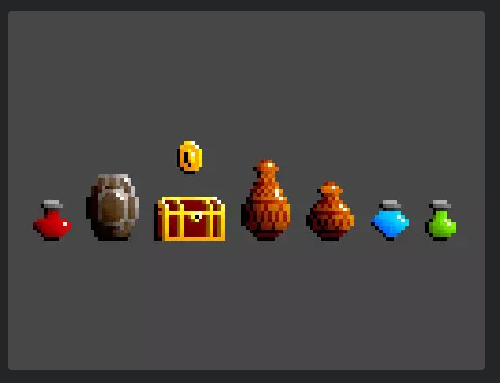***For the potion, ammo chest, and loot (coin)*

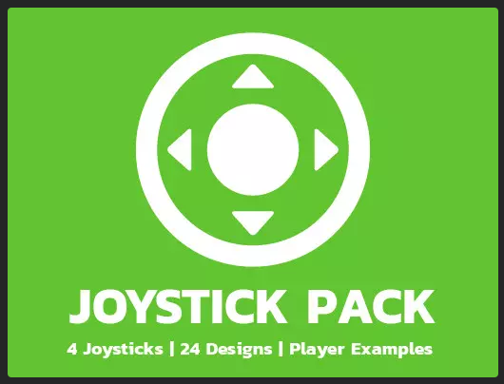 *For the player’s movement joystick controller*

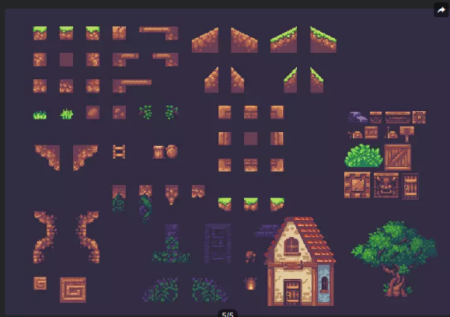 *For the grass blocks (movable platforms)***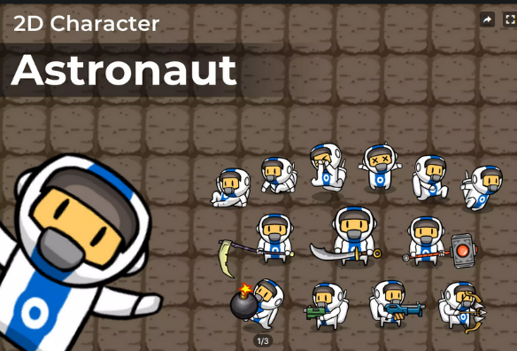** *For the player sprites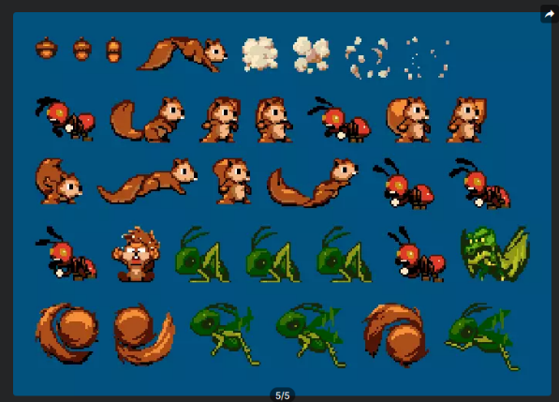For the ants, alligators, eagles and frogs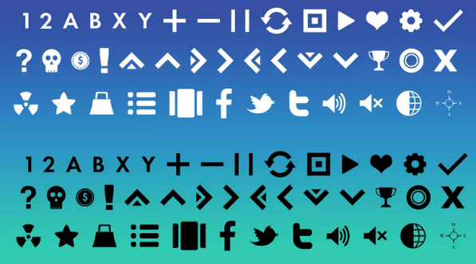For the down arrow icon in the instruction scene*

**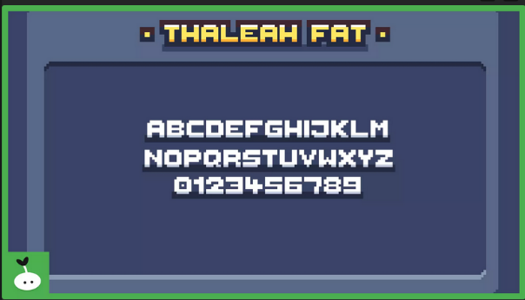***For the font used throughout the game (titles, texts, and the buttons)*

1. **Future Features**
2. *Create logic and gameplay functionalities*
3. *Possibly adding new enemies*
4. *Possibly adding new player attacks*
5. *Possibly adding more challenging levels*